Assignment 7: Investco Scout Fund Database (50 Points)
Grade Distribution:
Three original tables, 10 points each (30 Points)
Alter statement and revised table 10 point
SQL Queries 10 points

Read and Follow Instructions very carefully.

Instructions:
- Create a database based on the requirements given below. You should write SQL queries for creating database/tables and uploading data to the database you create.
- Once you created three original tables, you should add two more columns and load data to them in the table named “Investment_company.”
- HINT: 4 primary SQL commands you will be using: CREATE, INSERT, ALTER, UPDATE
- Name your database as Investco_ScoutFund.
- The name of the columns has been provided in the requirement table below. Make sure to use those column names only.
Deliverable:
Word document containing SQL queries and screenshots for all the tables. See the example below for the screenshot requirement. Ensure the Red Arrows information in the screenshot is evident in your submissions.

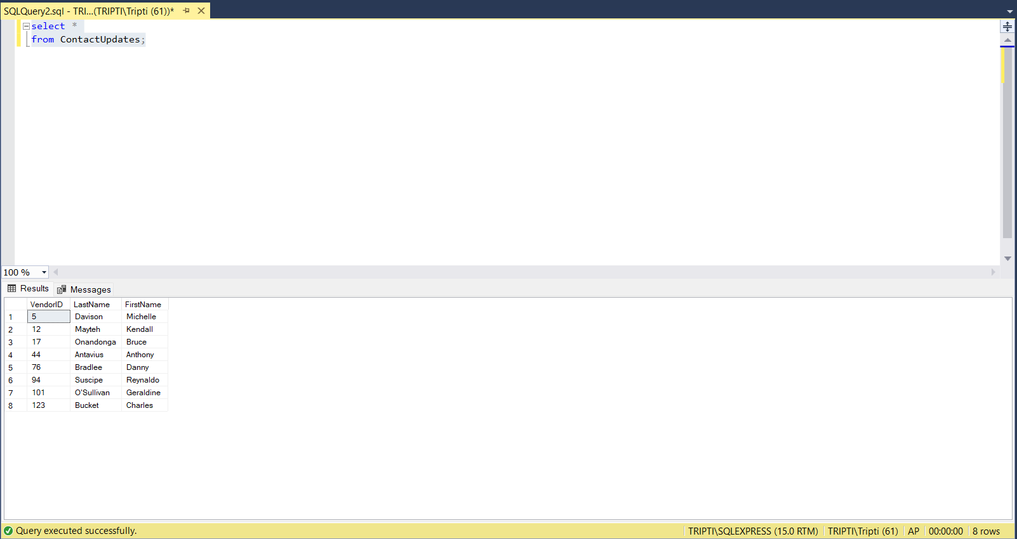
Your local instance of database engine
No of Rows

Part 1: Database requirements:
• The Investco Scout Funds Database will keep track of investment companies, the mutual funds they manage, and securities contained in the mutual funds.
• For each investment company, Investco Scout will keep track of a unique investment company identifier (ICID) and a unique investment company name (ICName)
• For each mutual fund, Investco Scout will keep track of a unique mutual fund identifier (MFID) as well as the mutual fund name(MFName) and inception date (MFIncDate).
• For each security, Investco Scout will keep track of a unique security identifier (SecurityID) as well as the security name(SecurityName) and type (SecurityType).
• Investment companies can manage multiple mutual funds. Investco Scout does not keep track of investment companies that do not manage any mutual funds. A mutual fund is managed by one investment company.
• A mutual fund contains one or many securities. A security can be included in many mutual funds.

Use table names as:
Investment_company
Mutual_funds
Securities
Column names | Characteristics
ICID | Char(3), NOTNULL
ICName | Varchar (30), Not null
MFID | Char(2) not null
MFIncDate | Date not null
MFName | Varchar (25) Not null
MFMix | Varchar (50) not null
SecurityID | Char(2) Not null
SecurityName | Varchar (25) not null
SecurityType | Varchar (25) not null
CEOFName | Varchar (25)
CEOLName | Varchar (25)

Data need to be inserted to the tables:
Investment_company table:
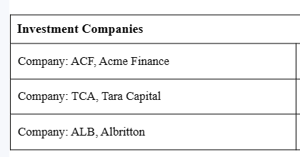
Mutual_funds table
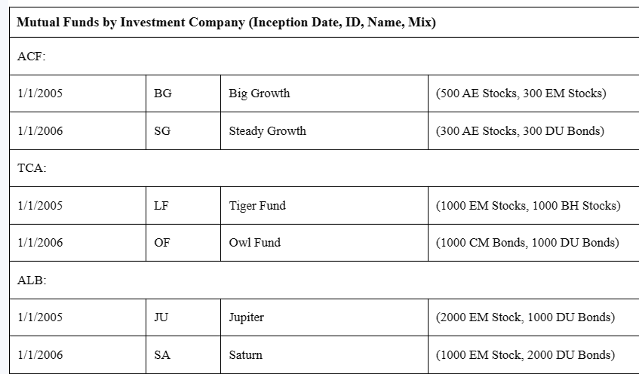
Securities table:
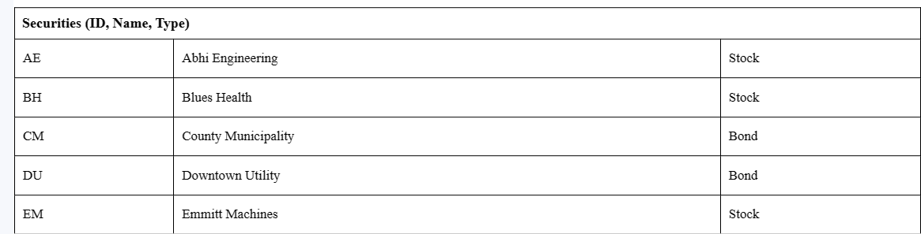
Once you have created all the tables, show their screenshots:

Part 2: Alter Investment_company table
Add CEOFname (varchar 25) and CEOLname (varchar 25) columns to Investment_company table and provide the SQL codes for such changes. Do not create those two columns in the beginning.
Data for revised Investment_company table:
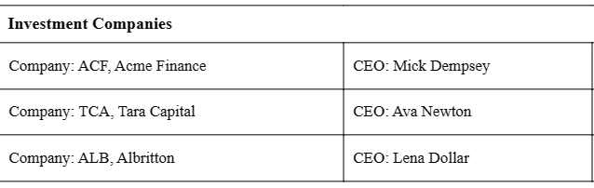

Extra Credit: 5 points.
This assignment has the option to earn five extra credit points if students can convert the requirement to a database design satisfactory and correctly recognize the missing information in the requirement section.

